Assignment Number: | ITB004.18
Assignment Name: | Access Assignment - Part B
Weighting: | 4%
Due Date: | Tuesday 9th May 2006.  Rather than leaving it to the last minute, you are strongly encouraged to start working on this part of the assignment. The relevant material is covered in:  lecture 8  tutorial and lab sessions that compliment that lecture, including the document “notes_on_Controls_and_Combobox”  the document “notes_on_using_combobox_to_find_record_on_form”  the notes and hints included in the body of the assignment.
Item to be Submitted: | For this part: the AccessAssign061_Videos.mdb database described in the main body of this assignment.
How to be Submitted: | The assignment must be submitted using the Online Assignment System (OAS).

Marking Guide \ Distribution of Marks
The marks shown are weighted marks and so the total of these marks is 4%.
Part marks will be given for a partly correct solution.
A late penalty will automatically be deducted for late assignments following faculty policy (see note (k) for SQL Assignment Part A).

Main form: Customer_Rented_Movies: (including source of data, but without combobox) 0.50%
combobox to select customer (not including list) 0.50%
combobox list 0.75%
subform control to hold subform 0.50%
Subform: Customer_Rented_Movies_SF: (not including source of data) 0.75%
subform source of data (query or SQL Statement) 1.00%

NB: If you fail to follow the instructions listed in the assignment (in particular see Do’s and Don’ts and Specific instructions) you may not achieve a maximum score despite the otherwise apparent correctness of your solution, i.e. you may lose marks. For example, if you use the wrong name for the form or subform you may lose marks.

The Database: Parts B and C
You are to use the AccessAssign061_Videos.mdb database from Part A for Part B and Part C of your Access Assignment work.

Do’s and Don’ts (for parts A, B and C of your Access assignment)
Before submitting your assignment(s), check that you have met all the requirements listed in this specification. You don’t want to lose marks for things that you think are unimportant, but the marker views differently.

- You are reminded that assignments in ITB004 are not group work (see note (a) for SQL Assignment Part A).

- You must follow all instructions given in the assignment specifications

- You must follow all naming conventions given in the assignment specifications or as indicated in the database provided. For example, you should name the form and subform you create as indicated in the specifications, and you should not change the names of any tables, or fields within tables, provided with the database. Failure to comply with these naming conventions will result in loss of marks, e.g. using different names for your form or subform, or changing the name of any of the tables or fields.

- If your database is too big to be accepted by the OAS, use Access to open it, then use the command Tools → Database Utilities → Compact and Repair Database (as indicated in lectures). After exiting from Access, your database should be small enough to submit. Hint: if you use background pictures for your form or subform or other stylised techniques such as colouring or shadow effects these tend to make the size of the database bigger. It is not recommended you use such effects, and there are no additional marks for doing so. If you experiment with such features it is recommended that you remove them before doing a final compact and repair and then submitting your assignment.

You’ll probably find it helpful to use the actual contents of the database to help you develop your answers. But, as before with the SQL assignments, there are two things to be careful about.

- When writing a query or SQL Statement you must not assume that particular rows are present (or absent) in the database. That is, your queries and SQL Statements must still give appropriate results, even if all the current rows were deleted and a completely different set of rows inserted, e.g. if the data were replaced with data concerning different videos, customers, etc.

- The data in the database can be used to help you develop your answers, but there is no requirement to use the given rows in that database, as it is given to you. In particular, there is no guarantee that the data in that database will be sufficient to test whether your answers always work correctly or not.

Some Notes for the Tasks in Parts B and C:

- Refer to Part A of the assignment for notes on using the Wizard.

The Task
Create the form Customer_Rented_Movies as shown in the figures below, in response to the question and specification following.
You should make the appearance of your form as close to that in the snapshots in this specification. Being able to follow a specification is an indication of your ability to communicate effectively with other IT professionals. In addition, it will assist the marking of your assignment. For example, using drastically different fonts etc can influence the look of your form, (and make it harder to mark). You are encouraged to try out your form (and other work) by modifying the data in the database, e.g. adding new rows, changing existing rows etc.

The assignment is intended to give you experience in using form tools typically found in a commercial database package. In particular, the assignment tests your knowledge and skills with respect to: subforms, comboboxes, and Group By or total queries.

The basic purpose of the form is to answer this question:
For a selected customer, which movies has that customer rented, how many times have they rented each such movie, and when was the most recent date each such movie was rented? (NB: assume the DueDate is the date a movie is rented, and include movies that have not yet been returned).

Figure 1: A typical example of the form Customer_Rented_Movies, showing details for the customer “Torres, Erik”. The customer’s name and address appear on the main form (Customer_Rented_Movies) and the details of the movies they have rented appear in the subform (Customer_Rented_Movies_SF). The subform is presented in continuous forms view.
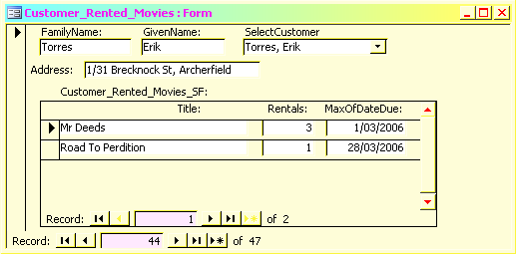

Figure 2: Another typical example of the form Customer_Rented_Movies, showing details for the customer “Tucker, Neil”.
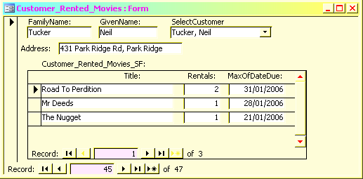

The finer details:

- The main form Customer_Rented_Movies shows the family name, given name, and address of the customer selected by the user, displayed in the Detail section of the form. The form is presented in single form view.

- In addition, the main form holds a combobox with the label “SelectCustomer” that enables rapid navigation to the customer selected in the combobox. The drop down list of the combobox (an example is shown in Figure 4) enables the user to select a customer from the Customers table, presented in alphabetical order of family name and then given name. The drop down list displays the given name and family name separated by a comma and space, telephone number and address of each customer. The user doesn’t see the CustomerNum in the drop down list. When the user selects a customer from the drop down list the details on the main form and the subform are changed to those of the customer selected.
Note: See the caveat at the end of this document regarding the use of the combobox.
[Hint: See the documents “notes_on_Controls_and_Combobox” and “notes_on_using_combobox_to_find_record_on_form”].

- Note: When the form is opened, the details of the first record in the Customers table (*) are displayed but the combobox will be blank (see Figure 3), i.e. the customer name for that customer will not be displayed in the combobox. This is OK. [(*) the first record in the Customers table will be the first physical record – it could be any customer].

- The main form holds a subform (Customer_Rented_Movies_SF) that shows the details of the movies rented by the customer selected. The subform is presented in continuous forms view.
The subform shows the title of each movie that the customer has rented, the number of times they have rented each such movie, and the most recent date each such movie was rented (NB: assume the DueDate is the date a movie is rented).
The list of movies in the subform is displayed in descending order of number of times rented and then by ascending order of the title of the movie.

Specific instructions (Read Carefully!)

- You must not use a query nor an SQL statement as the source of data for your main form.

- You must not use sub-queries in your query, or SQL statement, for the source of data for your subform.

- You must not use nested queries (or nested SQL Statements) in your query, or SQL statement, for the source of data for your subform. In other words, you must not use a query (or nested SQL Statement) in the FROM clause of another query, or SQL statement.

- You must name your main form: Customer_Rented_Movies. {note the underlines in the name – not spaces}.

- You must name your subform: Customer_Rented_Movies_SF. {note the underlines in the name – not spaces}.

- Think carefully about what is in your query, or SQL statement, before creating your form(s).

- Your query, or SQL statement, should have the minimum number of columns necessary for the subform.

- Your form(s) should be as shown in the figures throughout this specification.

Further Notes and Hints:

- Each form and subform must have a source of data. Think carefully about what is in each source of data before creating your form and your subform.

- Remember (from the lecture notes) that not all fields in the RecordSource of a form need appear on the form. Remember further that, where possible, the fields used to link a form with its subform should follow the primary key – foreign key relationship.

- When using the Form Wizard do so with care! Spend some time thinking about how the form-subform structure relates to the relationships between the tables in the database. You may find it helpful to review the lecture material on forms & subforms, in this regard. Remember also that the Control Wizards can be useful when adding a subform to a form.

- If you change any of the data accidentally, while experimenting with the form, there are a three possible ways to deal with this. Firstly, remember that the Undo button is available (if you notice the change early enough). Secondly, if you feel confident enough, you may like to change your form’s properties to prevent (accidental) changes. If so, look at the Allow properties, under the Data tab in the Form Properties dialog box. Thirdly, you may like to restart with a fresh copy of all the tables in the database, without losing all your queries, forms, etc. This is possible, but needs to be done carefully – Refer to the Moving Your Work to Another Copy of the Database section for instructions on how to move your work to another copy of the database.

Moving Your Work to Another Copy of the Database
Refer to Part A of the assignment for instructions on how to move your work to another copy of the database.

Figure 3: The form Customer_Rented_Movies when the form is opened. Note the combobox is empty–the user has not yet used the combobox to select a customer since opening the form.
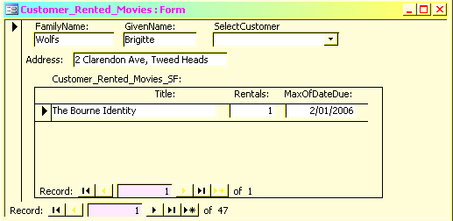

Figure 4: The form Customer_Rented_Movies; an example of the combobox drop-down list on the main form. The user is selecting the customer “Khaleyeva, Christopher”. Note, the combobox is empty – this is the first time the user has used the combobox to select a customer since opening the form.
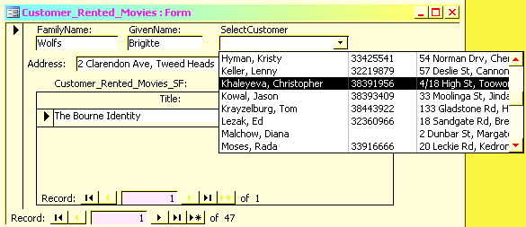

Figure 5: The form Customer_Rented_Movies. The user has selected the customer “Khaleyeva, Christopher”. Note, the combobox now displays the user’s selection.
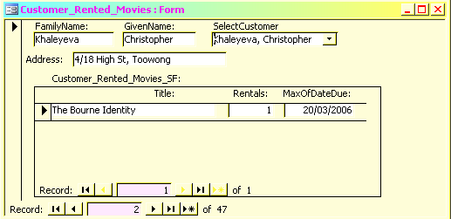

Caveat:
The user has used the navigation button to display a different record on the form to the one chosen through the combobox. This is shown in Figure 6, where the details for customer “Walker, Amy” are being displayed but the combobox retains the last selection made by the user when using the combobox – in this case “Tucker, Neil”.
For this assignment – this situation is OK.
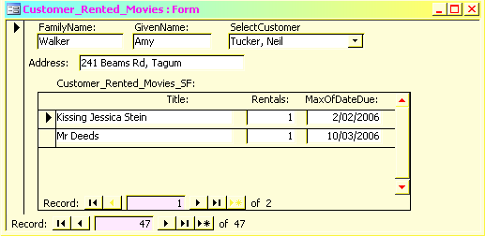

End of Assignment Specification.

